BEHAVIOR OF A PROBABILISTIC TABU SEARCH ALGORITHM FOR THE MULTI STAGE UNCAPACITATED FACILITY LOCATION PROBLEM

Yuri A. Kochetov and Eugene N. Goncharov
Sobolev Institute of Mathematics, 630090, Novosibirsk, Russia

ABSTRACT

A new Probabilistic Tabu Search algorithm for discrete optimization problems is presented. The algorithm uses randomized neighborhood with fixed threshold and applies adaptive rule to manage an active length of tabu list. It is shown that the algorithm generates a finite aperiodic and irreducible homogeneous Markov chain on a suitable set of outcomes. This property guarantees asymptotic convergence of the best found solution to the global optimum. New branch and tabu strategy based on a historical information of the previous search efforts is developed. In order to estimate the real behavior of the algorithm, we consider the Multi Stage Uncapacitated Facility Location Problem and present experimental results for a hard benchmark test set. Influence of neighborhood randomization, length of tabu list, aspiration criteria, intensification and diversification rules are studied.

KEYWORDS

Tabu Search, Markov Chain, Multi Stage Uncapacitated Facility Location Problem

1. Introduction

Tabu Search is one of the most powerful approaches for solving discrete optimization problems. It has been proposed by F. Glover [6,7] and was successfully applied to NP-hard problems in scheduling, location, routing, and others. This method can be easy adapted to complicated models and is simple to code. In contrast to the branch and bound algorithm, it does not use duality theory or linear programming relaxations. Unfortunately, we still know little about the behavior of the method, its asymptotic properties, and probability of finding an optimal solution, even for classical combinatorial problems.

The purpose of this paper is to present new theoretical and experimental results for Tabu Search. We design a new version of the Probabilistic Tabu Search (PTS) algorithm, and show that the algorithm generates a finite aperiodic and irreducible homogeneous Markov chain on a suitable set of outcomes. The set is the product of the feasible domain and a set of tabu lists. This property guarantees asymptotic convergence of the best found solution to the global optimum. In order to estimate the real convergence rate, we consider the Multi Stage Uncapacitated Facility Location Problem and present experimental results for a hard benchmark test set. Influence of neighborhood randomization, length of tabu list, aspiration criteria, intensification and diversification rules are studied for this strongly NP-hard problem. Further research directions are discussed as well.

2. Probabilistic Tabu Search

Consider the minimization problem of an objective function F(x) on the boolean cube B^{n}:
min { F(x)| x ∈ B^{n} }.
In order to find the global optimum F_{opt} = F(x_{opt} ) we apply PTS algorithm with the following features. Denote by N(x) a neighborhood of the point x and assume that it contains all neighboring points y∈B^{n} with Hamming distance d(x,y)≤2. A randomized neighborhood N_{p}(x) with probabilistic threshold p, 0<p<1, is a subset of N(x). Each y∈N(x) is included in N_{p}(x) randomly with probability p and independently from other points. It is clear that N_{p}(x) may range from being empty for arbitrary threshold 0<p<1 to including all points from N(x).

Consider a finite sequence {x_{t}}, 1≤ t ≤ k with property x_{t+1}∈ N(x_{t}). An ordered set ϕ = {(i_{k},j_{k}),(i_{k−1},j_{k−1}),…,(i_{k−l+1}, j_{k−l+1})} is called a tabu list if vectors x_{t} and x_{t+1} differ by coordinates (i_{t},j_{t}). The constant l is called the length of the tabu list. Note that i_{t} and j_{t} are defined as equal if the vectors x_{t} and x_{t+1} are differed by exactly one coordinate. By definition, we put i_{t} = j_{t} = 0 if x_{t+1} = x_{t}. Finally, let N_{p}(x_{t},ϕ) be a set of points y∈N_{p}(x_{t}) which are not forbidden by the tabu list ϕ. Obviously, N_{p}(x_{t},ϕ) may be empty for nonempty set N_{p}(x_{t}). Now PTS algorithm can be written as follows:

PTS algorithm
- Initialize x₀∈ B^{n}, F*:=F(x₀), ϕ:= ∅, t:=0.
- While a stopping condition is not fulfilled do
  - Generate neighborhood N_{p}(x_{t}, ϕ).
  - If N_{p}(x_{t}, ϕ)=∅ then x_{t+1}:=x_{t},
else find x_{t+1} such that F(x_{t+1})=min {F(y), y∈ N_{p}(x_{t},ϕ)}.
  - If F(x_{t+1})<F* then F*:=F(x_{t+1}).
  - Update the tabu list ϕ and the counter t:=t+1.

The algorithm does not use an aspiration criteria and differs form the well-known PTS algorithm [7] in two main properties. It may stay at the current point for some steps and may regulate an active length of tabu list. If l>|N(x)|, then all points may be forbidden and N_{p}(x, ϕ)=∅. In this case we obtain x_{t+1} = x_{t} on the step 2.2. and (i_{t},j_{t})=(0,0). In fact, this means that the length of tabu list is decreasing. This element of adaptation allows asymptotic properties to be obtained without any restrictions on the length of the tabu list.

Markov Chains

Suppose l=0. In this case, the selection of x_{t+1} depends on the current point x_{t} and does not depend on the previous points x_{τ} ,τ<t. We may say that the sequence {x_{t}} is a random walk on the boolean cube B^{n} or a Markov chain on the finite set of outcomes B^{n}. Now we recall some definitions [4]. A Markov chain is called finite if the set of outcomes is finite. It is called homogeneous if the transition probabilities do not depend on the step number. For l=0, PTS algorithm generates a finite homogeneous Markov chain on the boolean cube B^{n}. A Markov chain is called irreducible if for each pair of outcomes x, y there is a positive probability of reaching y from x in a finite number of steps. From the definition of N_{p}(x) it is follows that the Markov chain is irreducible. Hence, we have
$\text{Pr}\left\{\underset{τ≤t}{\text{min}}F(x_{τ})=F_{\text{opt}}\right\}→1,$ as t→ ∞.
Now we consider the general case l>0. Let Ω denote the set of all pairs (x, ϕ), where x∈B^{n}, and ϕ is a tabu list. We assume that the tabu list does not contain identical pairs with exception of the artificial pair {0,0}. Since the set Ω is finite, the sequence {(x_{t}, ϕ_{t})} is the finite Markov chain on Ω.

Theorem 1. For arbitrary l ≥ 0 and 0 < p <1 the PTS algorithm generates an irreducible Markov chain on Ω.

Proof. Let (x,ξ), (y,φ) be two arbitrary outcomes in Ω. We show that there is a positive probability to reach (y, φ) from (x, ξ) by at most ( ⎡n/2⎤ +3l ) steps. Denote by z∈B^{n} a point starting is from that we may hit the outcome (y,φ) by l steps. This point z exists and is defined by the tabu list φ uniquely. Consider a minimal length path from x to z and suppose that the algorithm generates the empty randomized neighborhood N_{p}(x,ϕ) during the first l steps, i.e. x=x₁=…=x_{l} , and ϕ₁= ξ, ϕ₁={(0,0),…,(0,0)}. It may happen with a positive probability. The path from x to z does not contain identical pairs, (i_{t} , j_{t} )≠ (i_{τ} , j_{τ} ) for τ ≠ t. Therefore, the algorithm can generate appropriate sequence of moving to reach z from x. Suppose again that the algorithm generates the empty sets N_{p}(z, ϕ) during the next l steps. We obtain the artificial tabu list once more and now the algorithm can reach the outcome (y,φ) from the point z.

The following asymptotic properties of PTS algorithm are straightforwardly derived from Theorem 1.

Corollary 2. For an arbitrary initial point x₀ ∈ B^{n} we have
1. lim_{t→∞} Pr{ min_{τ ≤ t} F(x_{τ} )=F_{opt}}=1;
2. there exist constants b>0 and 1>c>0 such that Pr{min_{τ ≤ t} F(x_{τ} )≠ F_{opt} }≤ bc^{t};
3. the Markov chain {x_{t},ϕ_{t}} has a unique stationary distribution π >0.

Proof. The first and the second properties immediately follow from the property of irreducibility. In order to prove the last statement, we need to check that the Markov chain is aperiodic. Since the neighborhood N_{p}(x,ϕ) may be empty then x_{t+1}= x_{t} for this case and the chain has required property. Hence, by the Ergodic Theorem [4] the chain has unique positive stationary distribution.

The first property guarantees that the algorithm obtains an optimal solution with probability 1 for sufficiently large number of steps. We can not say that the sequence {x_{t}} converges to an optimal solution as in the case of Simulated Annealing [1], i.e.
$$\underset{t→∞}{\text{lim}}\text{Pr}\left\{x_{t}∈X_{\text{opt}}\right\}=1,$$
where X_{opt} is the set of all optimal solutions. But for practical purposes this is unimportant. We can always select the best solution F* in the sequence {F(x_{τ} )}, τ ≤ t. A variant of PTS algorithm that converges can be found in [5]. The second property guarantees a rate of convergence with the constant c<1. The third property guarantees that PTS algorithm generates an ergodic Markov chain with a positive limiting distribution π(x,ϕ). So we can find a global optimum from an arbitrary initial point.

Variants of the Algorithm

Consider a modified algorithm when the tabu list ϕ is updated only for nonempty neighborhood N_{p}(x,ϕ). In this case, the artificial pair (0,0) does not belong to ϕ for any t. New variant of PTS algorithm generates a Markov chain on Ω as well. But now we can prove irreducibility for small values of l only.

Theorem 3. For arbitrary 0<p<1 and l<n(n-1)/4 the modified PTS algorithm generates an irreducible Markov chain on Ω .

Proof. Let (x,ξ), (y,φ) be two arbitrary outcomes, η denotes a set of all pairs (i,j), i<j, and φ₁ =φ \ η. The subset φ₁ contains all pairs (j, j), j≤ n from φ . If n is even, we may reach the outcome (y,φ) from (x,ξ) by the following way. We move from x according to the set η \ ξ . At the end of this path we obtain an outcome (x′,ξ′). Notice that the tabu list ξ′ does not contain the pairs (j, j), j≤ n since |η \ ξ |>l. Hence, we may reach arbitrary point z∈B^{n} from x′. For example, we may reach z′ which differs from the point (1–y) by coordinates from the set φ₁. Now we move from z′ according to the set η \φ and then according to the set φ in inverse order (see Fig.1). Since n is even, we hit the point y with the tabu list φ .

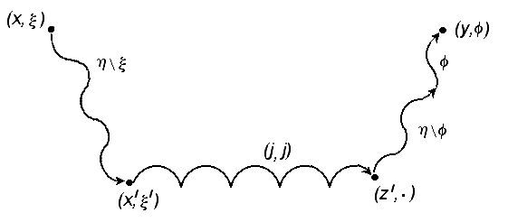
Figure 1. The path from (x,ξ) to (y,φ)

Let us verify that the path from (x,ξ) to (y,φ) does not violate the tabu list restrictions. At the initial stage, the tabu list ξ can not prevent to move according to the set η \ ξ . At the second stage, the tabu list ξ′ does not contain the pairs (j,j), j≤ n and we may reach z′. At the final stage, we face the most difficult case if x′=z′, ξ =φ , and l = n(n–1)/4 –1. In other words, we have to repeat the initial steps according to the set η \ ξ . As |η \ ξ |>l we can do it without violation of the tabu list restrictions. For odd n the proof is similar.

Consider another variant of the PTS algorithm. Denote by N_{r}(x,ϕ) a randomized neighborhood of x which contains exactly r≥ 1 unforbidden points of N(x). The algorithm with N_{r}(x,ϕ) neighborhood generates a Markov chain on Ω. Unfortunately, the analogous statement may be false for l>0. In particular, for l=|N(x)|− r we obtain the Deterministic Tabu Search (DTS) algorithm. If the tabu list is too small, DTS algorithm finds local optimum and has no opportunity to escape from it. Therefore, we need a large tabu list. Now we present an example of minimization problem for which DTS algorithm can not find the optimal solution for arbitrary large the tabu lists.

Suppose n is an even number, n ≥ 10. Let us consider the objective function F(x) = − | 4 − x₁ − … − x_{n} |. For x∈B^{n} the global minimum is 4 − n. We analyze the behavior of DTS algorithm for initial point x₀=(0,…,0). For convenience, we place all pairs (i,j), i≤ j in the triangular Table 1.

Table 1. All moving in the neighborhood N(x)

(1,1)
(1,2) | (2,2)
(1,3) | (2,3) | (3,3)
(1,4) | (2,4) | (3,4) | (4,4)
(1,5) | (2,5) | (3,5) | (4,5) | (5,5)
(1,6) | (2,6) | (3,6) | (4,6) | (5,6) | (6,6)
… | … | … | … | … | …
(1,n-1) | (2,n-1) | (3,n-1) | (4,n-1) | (5,n-1) | (6,n-1) | … | (n-1,n-1)
(1,n) | (2,n) | (3,n) | (4,n) | (5,n) | (6,n) | … | (n-1,n) | (n,n)

On the first step ϕ =∅ and it is necessary to find x₁ such that F(x₁)=min { F(y)| y∈N_{p}(x₀, ϕ)}. There are many optimal solutions for this problem. We select x₁ = (1,0,…,0) as the lexicographic maximal. The pair (1,1) is added to the tabu list, ϕ = {(1,1)}. The current value of objective function is −3. At the second step we get x₂ = (0,1,0,…,0), ϕ = {(1,2), (1,1)}, F(x₂) = − 3. On the third step we return to the initial point x₃ = x₀, ϕ = {(2,2),(1,2),(1,1)}, F(x₃)=− 4. The algorithm runs the first loop. Further it will return to x₀ several times by loops with length 3 or 4 steps (see Table 2).

Table 2. Behavior of DTS algorithm

Loops |  | Objective function
a) | (1,1), (1,2), (2,2) | -3, -3, -4
 | (3,3), (1,3), (1,4), (4,4) | -3, -3, -3, -4
 | … | -3, -3, -3, -4
 | (n-1,n-1), (1,n-1), (1,n), (n,n) | -3, -3, -3, -4
b) | (2,3), (3,4), (2,4) | -2, -2, -4
 | (2,5), (3,5), (3,6), (2,6) | -2 -2, -2, -4
 | … | -2 -2, -2, -4
 | (2,n-1), (3,n-1), (3,n), (2,n) | -2 -2, -2, -4
 | … | …
z) | (n-2,n-1), (n-1,n), (n-2,n) | -2, -2, -4

When the length of tabu list is too large, l ≥ |N(x)|, the DTS algorithm puts all pairs (i,j) from the Table 1 to ϕ and stops at the point x_{n(n+1)/2} = x₀. All moves are forbidden by the tabu list. The algorithm stays at the point x_{n(n+1)/2} for the l−|N(x)| steps and then repeats the path. Let l < |N(x)|. In this case, it is easy to find l′, l ≤ l′≤ l+3 such that the algorithm repeats the loops: the 1-st loop, the 2-nd loop,…, the k-th loop, and so on. In other words, for every l>0 we may find l′, l ≤ l′ ≤ l+3 such that DTS algorithm with the length of tabu list l′ can not reach the optimal solution.

5. Multi Stage Uncapacitated Facility Location Problem

Assume that [12]:
J : set of clients,
I : set of sites where facilities can be located,
K : number of distribution stages (levels),
P : set of all admissible facility paths.

We suppose P={p=(i₁,…,i_{K})| i_{k}∈I, k=1,…,K} and P_{i}={p∈P | i∈ p} is a set of facility paths which traverse the site i,
f_{i} ≥ 0 : fixed cost of opening facility at the site i,
c_{pj} ≥ 0 : production and transportation cost for supplying client j through the facility path p.

Decision variables:

z_{i} = 1, if facility is open at the site i,
0, otherwise,

y_{pj} ≥ 0 fraction of the demand of client j supplying through facility path p.

A mathematical formulation of the Multi Stage Uncapacitated Facility Location Problem (MSUFLP) can be written as the mixed integer linear programming problem [8,9,10,12]:

$$\text{min}$$
s.t. $\sum_{p∈P}{y_{\text{pj}}=1}$, $j∈J$,
z_{i} ≥ y_{pj} , i∈p, p∈P, j∈J,
z_{i}∈{0,1}, y_{pj} ≥ 0, i∈I, p∈P, j∈J.

The objective function is the total cost of opening facilities and supplying clients. The first restriction of the program requires that all clients be supplied. The second restriction requires that clients be supplied by open facilities only. For K=1 we obtain the well known Uncapacitated Facility Location Problem [3,11]. Hence, MSUFLP is strongly NP-hard.

For convenience, we rewrite MSUFLP as unconstrained integer program. Let us define new boolean variables

x_{p}= 1, if all facilities on the path p are open,
0, otherwise.

Now MSUFLP can be formulated as minimization problem with the following objective function

$\underset{}{}F(x)=\sum_{i∈I}{f_{i}\underset{p∈P_{i}}{\text{max}}}$
It is easy to verify that equations $x_{p}^{}=\underset{i∈p}{\text{min}}z_{i}^{},$$p∈P$, and $z_{i}^{}=\underset{p∈P_{i}}{\text{max}}x_{p}^{},$$i∈I$, are true for optimal solutions $x_{p}^{}$ and $z_{i}^{}$.

6. Computational experiments

We create random benchmarks for the MSUFLP with following parameters:
|J| = 100, |I| = 50, K = 4, |P| = 100, f_{i} = 3000, c_{pj}∈[0,4] integer, p∈P_{j} , |P_{j}| = 10.
The subsets P_{j} ⊂ P are generated at random. They indicate subsets of facility paths which are available for each client j. These benchmarks are closely related to the Set Covering Problem. We create 30 instances and solve them by the exact Branch and Bound algorithm [3, 8]. As a rule, the global optimum is unique. From 10000 to 50000 nodes in the branching tree are necessary to evaluate for getting optimal solution and proving the optimality. An average value of duality gap δ =100%(F_{opt} −F_{LP} )/F_{opt} for these benchmarks is about 45%, F_{LP} is the value of linear programming relaxation. For computational convenience, we redefine the neighborhood

N(x)=N_{ball}(x) ∪ N_{swap}(x),

where N_{ball}(x)={y∈B^{n} | d(x,y)≤1} and N_{swap}(x)={y∈B^{n} | ∃ unique pair (i,j): y_{i}=1−x_{i}, y_{j}=1−x_{j}, x_{i} ≠ x_{j}}. It is easy to verify that Theorem 1 and its corollary remain valid for the new neighborhood.

In Figure 1 we show an average relative error ε =100%(F*−F_{opt} )/F_{opt} as a function of threshold p for l=0, 10, 50. Total number of trials is 600=30 instances × 20 trials. It is surprising that the optimal threshold p* is very small, p*∈[3%, 8%]. For comparison, we have ε=11.1% for p=100%, l=50. Hence, DTS algorithm gets worse solution in average and takes more time, |N(x)| ≥ |N_{p}(x)|. It is interesting to note that the relative error ε is small for l=0. In other words, the simple probabilistic local search algorithm is quite well for appropriate value of threshold p. As we see in Figure 1, influence of the tabu list decreases as the neighborhood randomization grows. We may conclude that randomization of the neighborhood allows to decrease relative error, reduce running time, and relax the influence of the tabu list.

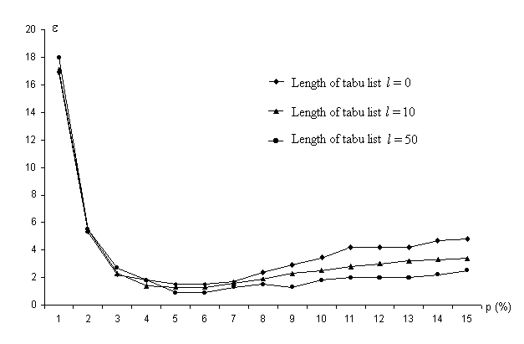

Figure 2. Average relative error of PTS algorithm for t=20000

In Figure 2 we present a frequency Fr{F*=F_{opt}} of the best found solution being optimal. We show this characteristic as a function of step number t. Four different strategies are studied in this computational experiment:

- single start,
- multi start with a new random initial point if the best value F* is not change through t′ =100 steps,
- multi start for t′ =500,
- branching start for t′ =500.

Figure 2 shows advantages of the branching strategy. According to this rule, we accumulate statistical information about the decision variables z_{i} during the search process. We select for branching some variables which most often turn out to be equal 1 and put z_{i} =1 ( intensification idea ). Number of branching variables is taken at random from 1 to 5. This rule reduces dimension of the original problem and transforms the initial data. As we see in Figure 3, this strategy exceeds other ones if approximation solutions are required as well.

To understand the influence of the aspiration criteria, we modify PTS algorithm on the step 2.2. If the neighborhood N(x) contains the best solution F(y)<F* and y is forbidden by the tabu list, we ignore the tabu and put x_{t+1}:=y. It is clear that the new algorithm does not generate Markov chain. We have tested the algorithm on the same instances and compared results. Unfortunately, we can find no advantages of the modified algorithm.

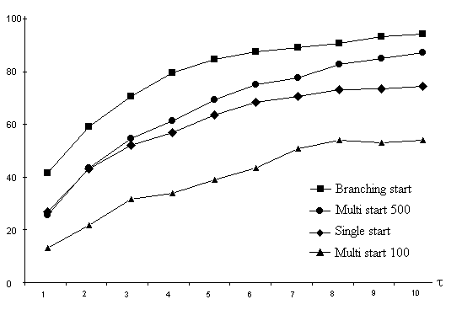

Figure 3. Frequency Fr{F*=F_{opt}} for t =2000τ, l =50

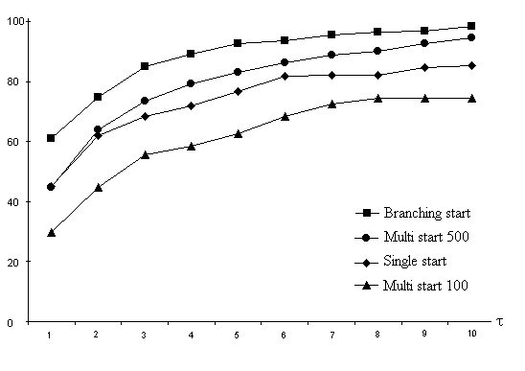

Figure 4. Frequency Fr{ε ≤ 1} for t =2000τ, l =50

7. Further Research Directions

For future research it is interesting to study more complicated algorithms, for example, PTS algorithm with variable threshold and (or) randomized variable neighborhoods. If we increase the threshold, the algorithm strives to investigate the current search area more carefully. When we decrease the threshold, the algorithm tries to change the current region. One of the research direction is to understand how to manage this control parameter to increase the probability of finding the optimal or near optimal solution for given number of steps.

Another direction is development of Probabilistic Branch and Tabu method. The exact Branch and Bound approach proves the idea of branching tree to be useful. As we see, the analogous ideas may improve the performance of the search methods. For PTS algorithm it can be based on the statistical information of the previous search efforts like the Ant Colony approach [2] or adaptive memory programming concepts [6]. Notice that the best branching rules for exact and search methods may be different.

Acknowledgements

This research was supported by Russian Foundation for Basic Research, grants 98-07-90259, 99-01-00510.

REFERENCES

- Aart, E. H. L., Korst, J .H. M., and Laarhoven, P. J. M. (1997) Simulated Annealing, in: Aart, E. H. L. and Lenstra, J. K., eds., Local Search in Combinatorial Optimization, Wiley, Chichester, 91-120
- Alexandrov D.A. (1998) The Ant Colony Algorithm for the Set Covering Problem. Proceedings of 11-th Baikal International School-Seminar, 3, 17-20 (in Russian)
- Beresnev, V., Gimadi, E., and Dement’yev, V. (1978) Extremal standardization problems. Nauka, Novosibirsk (in Russian)
- Borovkov A.A. (1998) Probability Theory, Gordon and Breach Science Publishers, Amsterdam
- Faigle, U. and Kern, W. (1992). Some convergence results for probabilistic tabu search. ORSA Journal on Computing, 4, 32-37
- Glover, F. (1989). Tabu Search. Part I. ORSA Journal on Computing, 1, 190-209
- Glover, F. and Laguna, M. (1997). Tabu Search. Kluwer Academic Publishers, Dordrecht
- Goncharov, E. (1998). Branch and bound algorithm for the two-level uncapacitated facility location problem. Discrete Analysis and Operations Research, ser.2, 5, 19-39 (in Russian)
- Goncharov, E. and Kochetov, Yu. (1998). Randomized greedy algorithm with branching for the multi-stage allocation problem. Proceedings of 11-th Baikal International School-Seminar, 1, 121-124 (in Russian)
- Goncharov, E. and Kochetov, Yu. (1999). Behavior of randomized greedy algorithms for the multi-stage uncapacitated facility location problem. Discrete Analysis and Operations Research, ser.2, 6, 12-32 (in Russian)
- Krarup, J. and Pruzan, P. (1983). The simple plant location problem: survey and synthesis, European Journal of Operational Research, 12, 36-81
- Tcha, D.W. and Lee, B.I. (1984). A branch-and-bound algorithm for the multi-level uncapacitated facility location problem. European Journal of Operational Research, 18, 35-43

Dr Alexandre Dolgui
Dept. of Industrial Engineering
University of Technology of Troyes
12 rue Marie-Curie, BP 2060
10010 Troyes Cedex, FRANCE

Dr Yuri Kochetov
Sobolev Institute of Mathematics,
pr. Akademika Koptyuga 4,
Novosibirsk, 630090, Russia,

